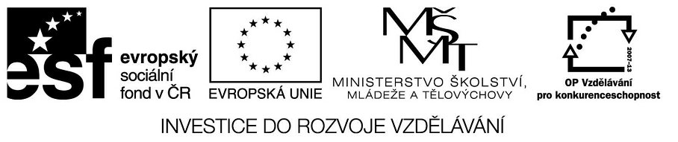

VY_32_INOVACE_23_11
Základní vzdělávání – Jazyk a jazyková komunikace – Anglický jazyk

Název materiálu – My name is Luca

Anotace – žáci prokáží schopnost pracovat s anglickým textem, prokáží čtení s porozuměním
a odpoví na základní otázky

Autor - Mgr. Radek Hulva

Jazyk – angličtina, čeština

Očekávaný výstup – žák doplňuje chybějící slova v textu, pracuje s dvojjazyčným
textem, využívá znalosti každodenních výrazů anglického jazyka

Speciální vzdělávací potřeby - žádné

Klíčová slova – missing words, expresions, Suzanne Vega

Druh učebního materiálu – pracovní list

Druh interaktivity - aktivita

Cílová skupina - žák

Stupeň a typ vzdělávání – základní vzdělávání – druhý stupeň

Typická věková skupina – 14 – 15 let

Celková velikost - 63 kB
My name is Luca
Suzanne Vega
My name is Luca
I live on the ………….. floor.
I live upstairs from ……….. .
Yes i think you've seen me before.
If you …………. something late at night.
Some kind of trouble, some kind of figur.
Just don't ………….. me what it was (3x)
I think it's 'cause i'm clumsy.
I try not to talk too loud.
Maybe it's because i'm ……………… .
I try not to act too proud.
They only hit until you cry.
And after that you don't ask …………….
You just don't argue anymore (3x)
Yes i think i'm……………………
I walked into the door again.
If you ask that's what i'll …………………
And it's not your business anyway.
I guess i'd like to be …………………
With nothing broken, nothing thrown.
Just don't ask me ……………… i am (3x)
My name is Luca
I live on the …………….. floor.
I live upstairs from you.
Yes i think you've seen me before.
If you ………………… something late at night.
Some kind of trouble, some kind of figur.
Just don't ask me what it was(3x)
They only hit until you cry.
And after that you don't ask ………………….
You just don't argue anymore (3x)
- Complete the sentences with missing words.
- What is this song about? (you can use also czech language to express your ideas.) Is this song about love or violance? Find any evidence for your statement.

- Answer following questions

- Who is Luca ?
………………………………………………………………………………………
- Where does she live ?
………………………………………………………………………………………

- What can you hear late at night?
………………………………………………………………………………………
- What is luca like? Try to find her characteristic in this song.
………………………………………………………………………………………
- How can you say following expresions in your language?
- I live upstairs from you.
………………………………………………………………………………………………
- And it's not your business anyway.
………………………………………………………………………………………
- I try not to act too proud.
………………………………………………………………………………………

