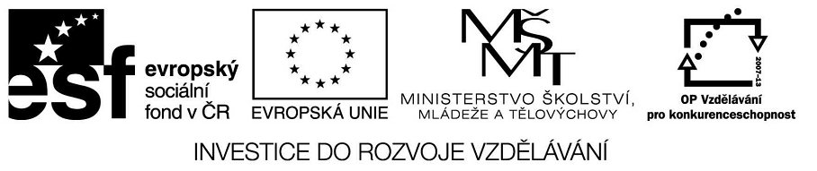

VY_32_INOVACE_23_15

Základní vzdělávání – Jazyk a jazyková komunikace – Anglický jazyk

Název materiálu – Present simple x present continuous.

Anotace – Žáci prokáží schopnost rozlišit tyto gramatické jevy v jednotlivých větách a
uvědomí si jejich správné použití

Autor - Mgr. Radek Hulva

Jazyk – angličtina, čeština

Očekávaný výstup – Žák je schopen popsat příběh na základě získaných znalostí.Žák je
schopen správně určit , popsat a rozlišit gramatické jevy.Žák je schopen
využít získané znalosti při popisu každodenních reálií

Speciální vzdělávací potřeby - žádné

Klíčová slova – present simple, present continuous, usually, normally, now,today

Druh učebního materiálu – pracovní list

Druh interaktivity - aktivita

Cílová skupina - žák

Stupeň a typ vzdělávání – základní vzdělávání – druhý stupeň

Typická věková skupina – 11-12 let

Celková velikost - 63 kB
Present simple X Present continuous

Peter is a 13 years young boy.Look at his schedule and write his story.Use present simple or present continuous.

On Saturdays This Saturday

7.30 wake up 7.45 wake up
8.00. have a shower 8.00 have bread and honey for breakfast
9.00 leave house 9.30 leave house
11.00 meet his best friend 11.00 help his mother with shopping
12.00 have a lunch with his family 12.00 have a snack in the local snackbar
14.00 watch his favourite series 14.00 go out with his cousin
17.00 play a football for school 17.00 visit his ill grandmother at hospital
football team
19.00 return back home 19.00 return back home from hospital
20.00 turn on tv a watch a favourite 20.00 read his book in his bed
Tv
22.00 switch off his light and go to 21.00 switch off his light and go to sleep
sleep

Use special adverbs for this grammar (usually,always,today,at this moment,normally……………………………)

…………………………………………………………………………………………………………………………………………………………………………………………………………………………………………………………………………………………………………………………………………………………………………………………………………………………………………………………………………………………………………………………………………………………………………………………………………………………………………………………………………………………………………………………………………………………………………………………………………………………………………………………………………………

3. Think about your Saturday. What do you usually do on Saturdays? What are you doing this Saturday? Write a short story. Use present simple or continuous.

………………………………………………………………………………………………………………………………………………………………………………………………………………………………………………………………………………………………………………………………………………………………………………………………………………………………………………………………………………………………………………………………………………………………………………………………………………………………………………………………………………………………………………………………………………………………………………………………………………………………………………………………………………………………………………………………………………………………………………………………………………………………………………………………………………………………………………………………………………………………………………………………………………………………………………………………………………………………………………………………………………………………………………………………………………………………………………………………………………………………………………………………

